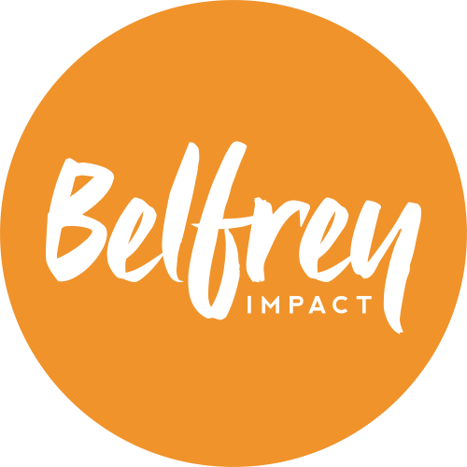

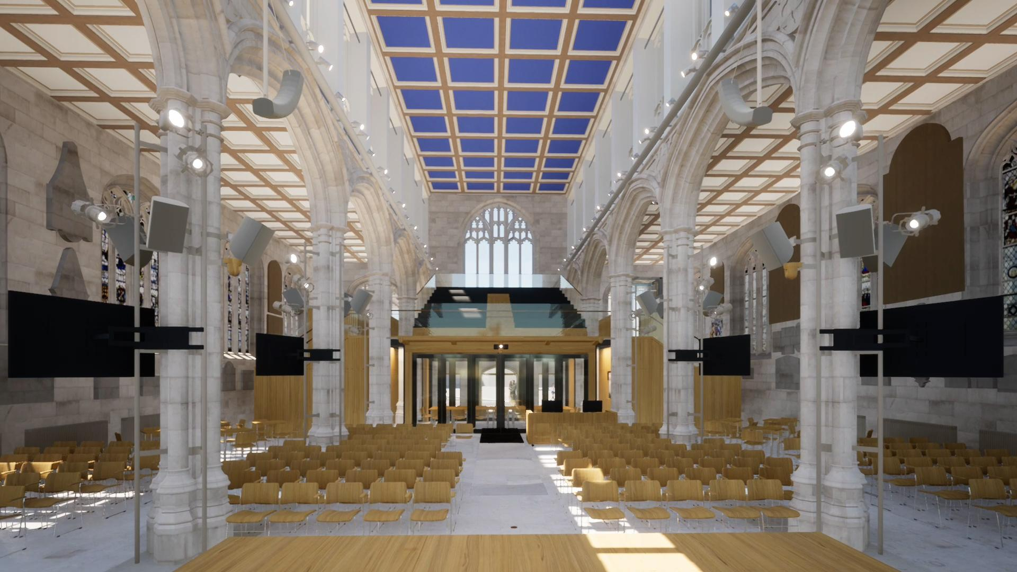

IMPACT COMMUNITY FUNDRAISING & ONLINE SHOPPING DONATIONS

This pack aims to provide all the info and tips you need to support Impact through these valuable fundraising routes.

INTRODUCTION

Impact is The Belfrey’s repair and reordering building project to transform our church building for generations to come. The Belfrey will become a more welcoming, accessible, flexible and beautiful space. It has been designed to reflect The Belfrey’s values of generosity, festivity, simplicity and humility and will support our five aims of Serving York, Making Disciples, Nurturing Disciples, Developing Leaders and Planting Churches.
So far Impact has attracted 80% (around £8m) of the funds it requires, which is incredible, but now we need the final £2m to complete the project. We launched the Fundraising campaign in October and are praying that up to £1m can be found through our church family making individual gifts and pledges to Impact. We are also applying to Trust Funds and seeking out Major Donors who will consider funding Impact and when they see the efforts we are making, it will encourage them to give.
There are two other important ways we can look to raise funds. Firstly, Community Fundraising or DIY Fundraising! This is where you can plan an event on your own, as a group, or take part in an organised sporting challenge to help raise funds for a cause or project, in this case Impact. Secondly, if you are an online shopper, you can donate money (at no cost to yourself) via the Easyfundraising website/app or AmazonSmile charity option. These portals will donate a small percentage of your purchases to us, when you nominate The Belfrey as your charity and will come to Impact. See page 7 for how to set these up.
Community fundraising means that everyone can get involved no matter what your age, experience or talents. Most importantly it gives you another way to take part in the life of The Belfrey and have an ownership in Impact, which we hope will be as valuable to you as it is to the church overall.

PLANNING A COMMUNITY FUNDRAISING EVENT
Below are some things to consider when planning your event:
What?
Firstly, consider WHAT you would like to do and with whom. You can organise your own event, plan something with your friends or Belfrey group, or take part in an organised event.
Perhaps there’s a sporting challenge you always wanted to do like cycle from Land’s End to John O’Groats or compete in the Great North Run…or is there a personal skill you’d like to put to the test? If there is something you love doing, whether it be playing a musical instrument, painting, climbing, football, dancing or baking, then you could put this to good use and help raise money for Impact.
Working out a fundraising idea with the help of others is probably easier as people can be there to cheer you on as well as advise and support. You will need to consider the logistics, volunteers, resources and any materials that you may need to run an event. It’s important that you and others stay safe in anything you end up doing, and under 18s in particular will need adult support. Consider what fundraising add-on events you could organise within an event. For example at a Games night with an entrance fee, you could also hold a lucky dip, cake sale or tombola.
We are here to offer advice and get creative to think through ideas with you.

When?
When choosing a date, avoid key holiday times, consider what the weather may be like, and check there are no other important big or local events that clash with your date. You will also need to co-ordinate with your preferred venue, if using one, and we can help with that. We would love it if you can run your fundraising activities over the next 6-8 months. Our aim is to bring in the majority of funding before we have to close the church building for construction which is currently expected to be summer 2023.

Where?
If you’re organising your own event, consider where you would like to hold it. The church building or Belfrey Hall could be an option, so talk to us and we can check availability. Holding your event in York or taking part in an event based in Yorkshire will generate the best support because it’s still relatively local to The Belfrey, your neighbourhood, workplaces and schools.

Who are you targeting?
Depending on your idea, think about who your audience might be or who you will invite – friends, church community, work colleagues, neighbours, general public?
How to bring in the funds?
You will need to think about how you gather people’s financial support. Will it be an event people pay to attend or participate in, or are you asking for donations or sponsorship?
We have set up an Impact JustGiving page to make life easy for us all – you can customise this to your own event and use it to gather sponsorship or donations. See our website belfrey.org/impact for details. Alternatively, you could use a paper sponsorship form that people fill in; set up a social media group for your activity where people are asked to register their support or ask people to donate/pay an entrance fee when they attend an event. Whatever works for you and your particular event, there is no right or wrong way. We may be able to support you centrally with booking a Belfrey venue and ticketing, if appropriate.
Alternatively donations can be made by bank transfer to:
St Michael le Belfrey PCC
16-34-80
11289130
NOTE: THIS IS OUR IMPACT ACCOUNT AND A DIFFERENT ONE TO OUR NORMAL BELFREY ACCOUNT.
Co-ordination of Events
Before you start planning your event in earnest please complete the Event form online (or request a hard copy). Send this to Heidi or Gillian on the Impact team - fundraising@belfrey.com
This way we can co-ordinate all the events being organised, and prevent clashes and duplication. Email or call us on 01904 624190 with any questions or to discuss ideas.
If you are not sure about a particular aspect of an activity, we can discuss the support you may need and make sure that it fits with The Belfrey’s mission and values. We can also help you check that it meets safeguarding and health and safety guidelines.

Remember to Promote your Event
It will be good to promote your activity to raise interest and encourage people to support you. We can help you plan your PR activity, make sure activities work in the diary and are communicated well. If you choose to fundraise in partnership with another organisation, such as a local sports club, we can help you with PR so it positively promotes both organisations. Avenues for promotion could include: The Belfrey Friday newsletter and website; emails; relevant social media pages on Instagram, Facebook (create an event or promote via church/community pages) and Twitter; and WhatsApp/Messenger groups.

Keeping Safe and Following the Law
Check what permissions you need to hold your event and whether you need any special insurance (and again we can help you with that). For example children and young people under 16 cannot legally carry out street or house-to-house collections, raffles and organising events involving alcohol. Under 16s can receive monies (such as an admissions desk) but must not have overall responsibility.
See https://www.fundraisingregulator.org.uk/code for details on the fundraising code of practice.
If you serve food and drink make sure you are aware of the UK regulations. See www.food.gov.uk

FUNDRAISING IDEAS

Here are just some of the things you could do…

- Football match or five-a-side tournament – football is such a popular sport in the UK whether you play it or watch it. Could you set up a football match with people in the church where people pay to play and pay to watch, or host one of the big games and provide some refreshments and charge an entrance fee
- Car Wash – offer to wash cars for family and friends
- The Belfrey Bake-Off – Baking in the UK is a big thing! You could run a competition and encourage people to pay to enter or people to pay to watch the competition or simply hold a Bake sale which will always attract people.
- Fashion & Craft - It could be a Sewing Bee, Fashion show, Clothes swap night or a craft making afternoon
- Auction of Promises – An auction that offers people’s gifts and talents and turns them into something that people can bid for. Someone might offer a haircut, a manicure, cook a meal or help with the garden.
- Lecture – if you are studying a particular subject and can give a lecture or demonstration on what you are learning, people may be very interested to pay for a ticket. You could do this in connection with a College or University Department
- Art exhibition - draw or paint pictures and hold an exhibition for your friends and family – they could pay to view or view for free and buy one of your artworks.
- John O’Groats to Land’s End –cycle it for real or row/cycle the distance in the gym
- Everest challenge – choose a hill and cycle/walk up and down the equivalent of Everest; or walk on an uphill treadmill the equivalent distance over x days!
- Swim The English Channel - swim the length of the channel in your local pool
- Walk the Yorkshires 3 Peaks / National 3 Peaks
- Running - 10K, half marathon, marathon or triathlon
- Organise your own Fun Run
- Cream tea party
- Cake n Coffee morning
- Pancake flipping competition
- Dance-a-thon
- Silent Disco
- Knit-a-thon
- Murder mystery
- The Belfrey Vision Song Contest
- Karaoke singing competition
- Music or band nights
- Groom a dog
- Bingo!
- Games night
- Trivia quiz night
- Sponsored Silence
- Sponsored Walk
- Read-a-thon
- Pizza & Film night
- Treasure hunts
- Jazz night
- Organise a fun sports day – egg and spoon races, three-legged races, sack rack
- University challenge
- Zumba night

The options are endless! Follow your passions and interests and plan an event that’s right for you.
You can plan events where you ask for sponsorship or donations for a challenge you are participating in, or charge an entrance fee to view or participate in an event.

SUCCESSFUL FUNDRAISING TOP 10 TIPS

Here are some gems from successful fundraisers:

- Prepare Well.
A successful event is the result of good planning. Make sure you think things through fully. Allow yourself plenty of time in the lead up to your event.
- Have a contingency plan.
Things can go wrong and sometimes do. Have a backup plan that can help you get back on track.
- Keep people informed.
Regular updates and photos about your event will keep people’s attention and interest.
- Get Fit. Stay Fit.
If you decide to do a physical challenge, then make sure you do enough preparation and training to give you the best chance of achieving your goal.
- What are others doing?
Looking at what other people are doing may inspire you too and give you new ideas.
- Make good use of the technology
Social media is an easy way to reach family, friends and the public to get them involved.
- Getting more sponsors
Will your employer allow you to send an email around your workplace asking for sponsorship? Perhaps you could put up a poster on a Community notice board. Or talk to Heidi and Gillian to see if your local media might do a feature.
- Keep Going
Not everyone is going to sponsor you straight away. Don’t let that discourage you. Ask again using a different request method eg. Social media to personal conversations. People sometimes just need a reminder.
- Be realistic
Try to strike a balance between an achievable target and a challenge. If you set your target too low, then people will not feel pushed to help you achieve it. You could look at what others have raised in similar events and add a little more.
- Remember the WHY
Don’t lose sight of the WHY. It is most important to keep you inspired but also to let others know why they should help you achieve your goal. Impact will help The Belfrey become a great place to worship, visit and participate in that will be accessible for all.

ONLINE SHOPPING DONATIONS

If you are an online shopper you can donate to the Impact project every time you buy online, at no cost to yourself! Simply by shopping via Easyfundraising or AmazonSmile and selecting St Michael le Belfrey as your chosen charity we will receive a small percentage of the purchase price, which will come to Impact. This is a simple way for The Belfrey to raise funds and it requires no real effort from individuals. Over time and multiple use across the congregation this form of fundraising could add up to a considerable sum!

Easyfundraising

You can shop online with 7000 retailers by going via the Easyfundraising.org.uk website or using the Easyfundraising app. Whether you’re buying some trainers, booking a holiday, doing your weekly food shop, looking for gifts, or searching out the best mobile phone deal, the majority of retailers are on here! With each retail purchase the retailer will give a small percentage (up to 5%) to Easy Fundraising, which is passed onto us.

Go to www.easyfundraising.org.uk and register yourself to create an account, then nominate St Michael le Belfrey as your chosen charity. Once you’ve registered you can:
- Go to www.easyfundraising.org.uk to shop. For ease of use, we suggest you add an extension to the browser on your PC - this is a small icon on the top right hand corner. Click on it each time you want to shop online and choose your retailer. It will redirect you to the website and you shop as normal.
- For smartphones or tablets - Download the Easyfundraising app in the App store for apple devices or Google play for android - login and choose your retailer. It will redirect you to start shopping as normal.

Amazon

Shopping with Amazon is a bit different and utilises AmazonSmile for charity giving, which you can use via the Amazon app or website.

Go to smile.amazon.co.uk to register and nominate ‘The Parochial Church Council of the Ecclesiastical Parish of St Michael le Belfrey with St Cuthbert, York!’ as your charity.
- For a PC - bookmark smile.amazon.co.uk for future use and shop as usual. You must shop via the smile version of Amazon for donations to be activated
- For a smartphone or tablet - download the latest version of Amazon (via Apple app store or Google Play); open the app and go to ‘Gifting and Charity’ (under the 4 bars at the bottom right hand corner on an iphone) and click Amazonsmile; then turn ON donations. Continue shopping through the app as normal.
(Note: not all purchases activate a donation as it depends upon the Supplier)

IMPACT COMMUNITY FUNDRAISING EVENT FORM
Prior to organising your event in full please complete and return this form to the Impact team so we can co-ordinate all activities. (See the website for an online version):
Name of Organiser: -----------------------------------------------------------------------------------
Contact Number: -----------------------------------------------------------------------------------
Email: -----------------------------------------------------------------------------------
Proposed Event: -----------------------------------------------------------------------------------
-------------------------------------------------------------------------------------------------------------------
Proposed Date: -----------------------------------------------------------------------------------
Proposed Location: -----------------------------------------------------------------------------------
Health & Safety
or Risks involved?: -----------------------------------------------------------------------------------
-------------------------------------------------------------------------------------------------------------------
What social media/promotion are you planning?----------------------------------------------------
--------------------------------------------------------------------------------------------------------------------------------
Please make sure your activity demonstrates honesty and integrity and fits with The Belfrey’s values of generosity, festivity, simplicity and humility. If you don’t have all the answers, complete any details you have so far and we’ll be happy to help.
Please return to fundraising@belfrey.org
To ask for support or talk through ideas contact:
Heidi Folland or Gillian Shepherd
fundraising@belfrey.org / 01904 624190
The Parish Centre, 11 Minster Yard, York YO1 7HH
www.belfrey.org/impact
THANK YOU FOR YOUR SUPPORT

